Enterprise Data Architecture & Reconciliation

Project Report

Submitted by:
Kushagra Tamang

PROJECT OVERVIEW
This project focuses on building an enterprise data reconciliation pipeline for a FinTech company. The objective is to combine data from multiple systems, clean and transform the data, reconcile transactions with daily exchange rates, identify active customers, and generate reliable financial insights.
The project works with three main data sources: a historical customer database, unstructured server transaction logs, and daily EUR-to-USD exchange rates. The data requires SQL-based filtering, regular expression extraction, temporal reconciliation, and efficient data processing.
The final objective is to calculate USD revenue accurately and provide business insights through monthly revenue analysis and identification of the top five customers by revenue.

Project Objectives
- Identify customers whose latest status is Active.
- Extract transaction information from unstructured server logs.
- Remove corrupted/error transaction records.
- Reconcile transactions with daily EUR-to-USD exchange rates.
- Handle missing weekend exchange rates using forward-filling.
- Calculate total USD revenue.
- Analyse monthly revenue trends.
- Identify the top five customers by revenue.
- Present the results using visualisations.

DATA SOURCES
The project uses three primary data sources:
1. Enterprise Database
A SQLite database containing historical customer records. Each customer can have multiple records because their status changes over time. The latest record for each customer is required to determine their current status.
2. Server Logs
A text file containing approximately 100,000 transaction log records. The transaction details are stored inside unstructured text strings rather than separate columns. The required information includes transaction date, User ID, Product ID, and Euro transaction value.
3. Daily Exchange Rates
A CSV file containing daily EUR-to-USD exchange rates. Exchange rates are unavailable for certain weekend dates because the market is closed. These missing rates need to be handled before joining the transaction data.

Key Data Challenges
- Historical customer records with multiple updates.
- Transaction information stored inside unstructured text.
- Error records mixed with successful transactions.
- Missing exchange rates on weekends.
- Large dataset requiring efficient processing without Pandas loops.
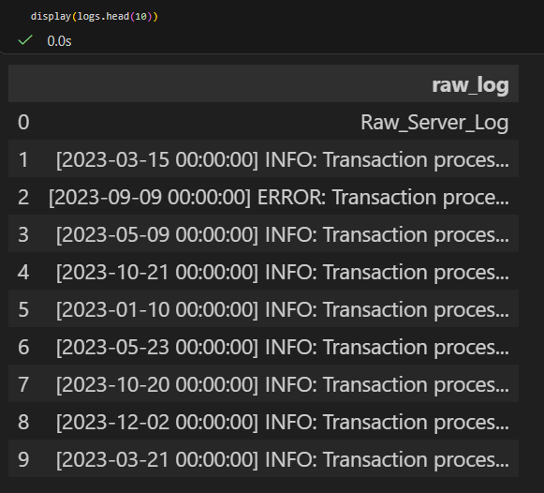
Figure 1: Raw server logs
SQL-Based Active User Extraction
The enterprise database contains historical records for customers because their account status can change over time. Therefore, simply selecting customers with an "Active" status could return outdated records. To identify the current status of each customer, a SQL window function was used to rank records by updated_at in descending order for each user_id. Only the latest record was selected, and customers whose latest status was "Active" were retained.

SQL Query
WITH ranked_users AS (
SELECT
user_id,
name,
status,
updated_at,
ROW_NUMBER() OVER (
PARTITION BY user_id
ORDER BY updated_at DESC
) AS rn
FROM users
)
SELECT
user_id,
name,
status,
updated_at
FROM ranked_users
WHERE rn = 1
AND status = 'Active';
Result: The query identified 14,183 customers whose latest recorded status was Active.
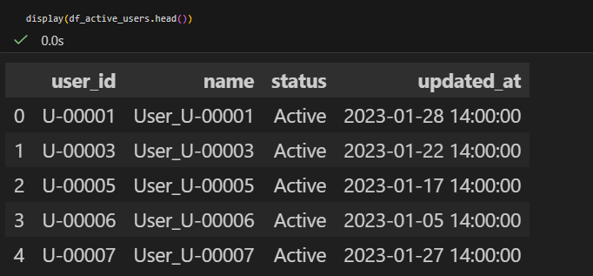
Figure 2: Active users
SERVER LOG CLEANING & REGEX EXTRACTION
The server log file contained approximately 100,000 records in an unstructured text format. Successful transactions were stored as INFO messages, while corrupted or failed transactions were marked as ERROR. The error records were removed before extracting the transaction information.
Regular expressions (Regex) were then used to extract the transaction date, User ID, Product ID, and Euro transaction value from each log entry.

Data Cleaning
The ERROR records were filtered out because they did not contain a valid eur_val field. The header-like record was also removed from the dataset. After cleaning, 94,902 valid transaction log records remained.
Regex Extraction
extracted_data = logs["raw_log"].str.extract(
r'\[(\d{4}-\d{2}-\d{2}) .*?"u":"(U-\d+)".*?"item_code":"(PRD-\d+)".*?"eur_val":([\d.]+)'
)

extracted_data.columns = [
"Date",
"User_ID",
"Product_ID",
"EUR_Value"
]
The extracted dataset was validated to ensure that the required fields were successfully captured. No missing values were found in the extracted Date, User ID, Product ID, or EUR Value fields.
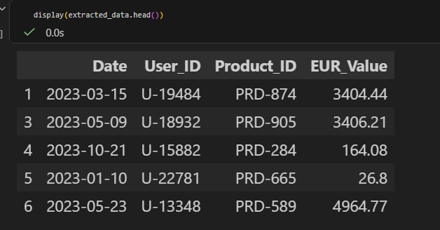
Figure 3: Regex-extracted transaction data
EXCHANGE RATE RECONCILIATION
The transaction values were recorded in EUR, while the final financial analysis required USD revenue. Therefore, the daily EUR-to-USD exchange rate dataset was used to convert each transaction into USD.
The exchange-rate dataset contained missing values for certain dates because financial markets are closed on weekends. An inner join would cause transactions occurring on these dates to be removed. To prevent this data loss, the missing exchange rates were filled using the previous available rate through forward-filling (ffill).

Forward-Filling Missing Exchange Rates
exchange_rates["EUR_to_USD"] = exchange_rates["EUR_to_USD"].ffill()

After forward-filling, the exchange-rate dataset contained no missing exchange-rate values. This ensured that transactions could be matched with an exchange rate even when the transaction occurred on a weekend.

Date-Based Reconciliation
extracted_data["Date"] = pd.to_datetime(extracted_data["Date"])
exchange_rates["Date"] = pd.to_datetime(exchange_rates["Date"])

extracted_data = extracted_data.merge(
exchange_rates,
on="Date",
how="left"
)
Both datasets were converted to a common date format and merged using the transaction date. This allowed each transaction to receive the appropriate EUR-to-USD exchange rate.
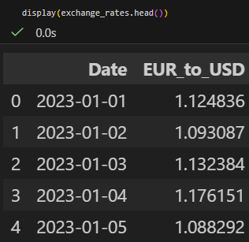
Figure 4: Forward-filled exchange rates
DATA INTEGRATION & USD REVENUE CALCULATION
After reconciling the transaction data with the exchange-rate dataset, the transactions were matched with the active customer list. An inner join was used to retain only transactions belonging to customers whose latest status was Active.
The EUR transaction values were then converted to numeric values and multiplied by the corresponding EUR-to-USD exchange rate to calculate USD revenue.
Filtering Active Customers
extracted_data = extracted_data.merge(
df_active_users[["user_id"]],
left_on="User_ID",
right_on="user_id",
how="inner"
)
After matching the transactions with the active customer list, 53,899 transactions remained for the final analysis.

USD Revenue Calculation
extracted_data["EUR_Value"] = pd.to_numeric(
extracted_data["EUR_Value"]
)

extracted_data["USD_Revenue"] = (
extracted_data["EUR_Value"] *
extracted_data["EUR_to_USD"]
)

df_final = extracted_data.copy()
The final dataset contained 53,899 transactions with no missing values in the required fields. Each transaction now contains its date, customer, product, EUR value, exchange rate, and calculated USD revenue.
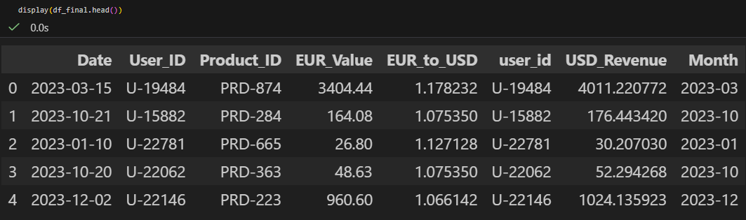

Figure 5: Final reconciled dataset

BUSINESS ANALYSIS
Monthly USD Revenue
Monthly revenue was calculated by grouping the final reconciled transactions by month and summing the calculated USD revenue. This provides management with a clear view of revenue performance throughout the year.
df_final["Month"] = df_final["Date"].dt.to_period("M")

monthly_revenue = (
df_final.groupby("Month")["USD_Revenue"]
.sum()
.reset_index()
)

Top 5 Customers by Revenue
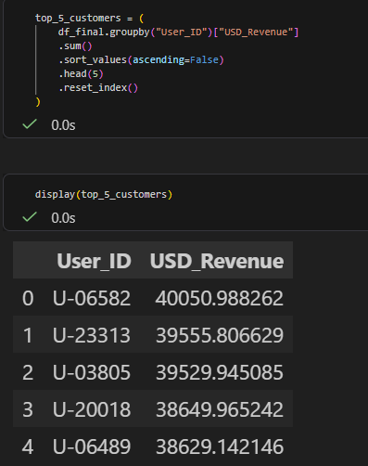
Figure 6: Top 5 Customers table

The analysis identifies the highest-value customers by total USD revenue contribution. Management can consider these customers important when evaluating revenue concentration and customer value.

VISUALIZATIONS
The final analysis was presented through visualisations to make revenue trends and customer contribution easier to understand. Two key visualisations were created: monthly USD revenue and the top five customers by USD revenue.

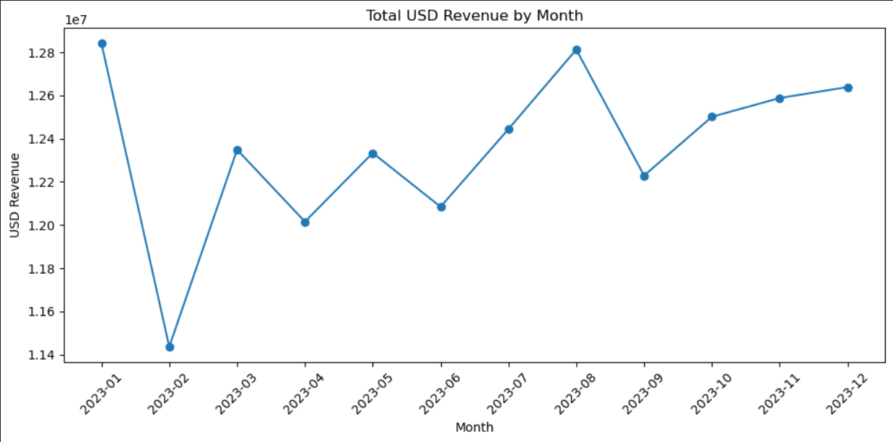
Figure 7: Total USD revenue by month

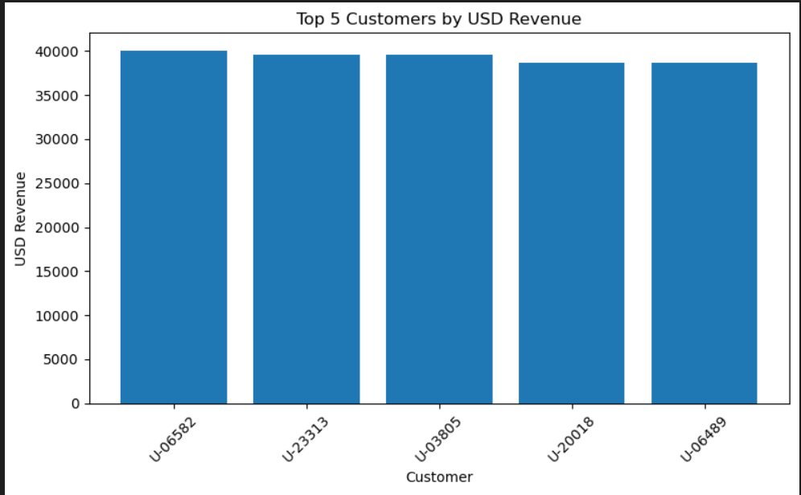
Figure 8: Top 5 customers by USD revenue
CONCLUSION & KEY FINDINGS
This project successfully demonstrated an end-to-end enterprise data reconciliation process using SQL and Python. Historical customer records were analyzed to identify customers whose latest status was Active. Unstructured server logs were cleaned by removing error records and extracting transaction information using Regex.
Daily EUR-to-USD exchange rates were reconciled with transaction dates, including missing weekend rates through forward-filling. The resulting data was then integrated with the active customer data and used to calculate USD revenue.
The final analysis provided monthly revenue trends and identified the top five customers by total USD revenue. These outputs provide a clear view of financial performance and customer contribution and can support management in financial reporting and decision-making.

Key Results
- 14,183 customers were identified as currently Active.
- 94,902 valid transaction records remained after removing error logs.
- 53,899 transactions remained after filtering for Active customers.
- Missing exchange-rate values were successfully handled using forward-filling.
- USD revenue was calculated for the final reconciled transaction dataset.
- U-06582 was the highest-revenue customer among the top five customers.
- Monthly revenue analysis showed fluctuations throughout 2023, with the highest level occurring around January and another strong peak in August.

Overall, the project demonstrates how multiple enterprise data sources can be cleaned, reconciled, integrated, and transformed into meaningful business insights through an efficient data pipeline.

